Grated Parmigiano Reggiano from Italy contains zero cellulose

Petaluma, CA, February 19, 2016: Recent reports have shown that some domestic pre-packaged grated cheeses using the name Parmesan contain illegal amounts of cellulose while it is never present in Parmigiano Reggiano.

Cellulose is a plant fiber made from wood pulp used in many food products in the United States. While legal in the U.S. in specific small amounts, cellulose is however never present in Parmigiano Reggiano which adheres to strict EU specifications where additives of any kind are not permissible.

Parmigiano Reggiano, a guaranteed PDO cheese (Protected Designation of Origin), is available in wedges to eat on its own, use in recipes or to grate at home as well as in certified pre-packaged tubs of grated product. While freshly grating a wedge of Parmigiano Reggiano at home is the best way to maximize freshness and flavor, grated Parmigiano Reggiano is available from licensed pre-packers who work directly with producers in Italy and export genuine pre-grated Parmigiano Reggiano that has been grated in the area of origin adhering to all production regulations. When buying pre-packaged grated Parmigiano Reggiano look for the Consorzio of Parmigiano-Reggiano logo (see image below) to ensure you are eating a pure product with no additives of any kind.
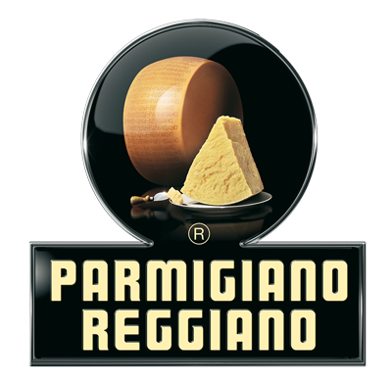

Grated 100% Parmigiano Reggiano with no additives is also available for purchase in non-branded deli cups in many stores though as they are grated at the store level outside the production area means they cannot be certified by the Consorzio. However as Parmigiano Reggiano is aged for long periods in low humidity and made from unadulterated partially skimmed raw milk, this eliminates any need for additives such as cellulose ever being added. On the contrary lower quality cheeses with short aging periods require these additives to maintain their texture.

Known as the “King of Cheeses” and “the ONLY Parmesan,” Parmigiano Reggiano has long battled domestic hard grating cheeses using the name Parmesan, which implies that something is “from or of Parma”, a city in Italy within the zone of origin for Parmigiano Reggiano. In 2008 an E.U. court ruled that the name Parmesan could no longer be used for any cheese other than Parmigiano Reggiano. This protection however does not extend to the United States where countless domestic imitations still use the name.

# # # #

Media Contact: Danielle Caponi Bolla, Ponte PR 707.971.0786
Consorzio Parmigiano-Reggiano USA Promotions and Marketing

